|  |  |
| --- | --- |
|  | **EDITORIAL:**  PSYCHOLOGICAL FIRST AID IN PAKISTAN:  **06** THE NEED OF THE HOUR  *NIGHAT HAIDER, /MT/AZ AHMAD DOGAR, MOWADAT H RANA*  **ORIGINAL ARTICLE:**  CAREER SATISFACTION AMONG PAKISTANI WORKING AND NON-WORKING  **08** FEMALE DOCTORS & THE REASONS TO DISCONTINUE MEDICAL PROFESSION  *MUHAMMAD IQBAL AFR/DI, DAN/YA KHAN, SUBAS ALI, RAKSHANDA SIDDIQI,*  *MARIAM ABDUL RAUF*  **ORIGINAL ARTICLE:**  OBSESSIVE BELIEFS IN PATIENTS WITH OBSESSIVE COMPULSIVE  **12** DISORDER; THE ROLE OF ATTACHMENT STYLES  *SARA ASAD, SA/MA DAWOOD*  **ORIGINAL ARTICLE:**  FREQUENCY OF NON MOTOR SYMPTOMS AMONG  **16** PATIENTS OF PARKINSON'S DISEASE IN PAKISTAN  *IMRAN AHMAD, USAMA BIN ZUBAIR*  **ORIGINAL ARTICLE:**  HEALTH RELATED QUALITY OF LIFE IN FEMALE PATIENTS WITH BRONCHIAL  **20** ASTHMA AND POST MENOPAUSAL OSTEOPOROSIS: A COMPARATIVE STUDY  *SADIA SALEEM, ZAHID MAHMOOD, FATIMA NAEEM*  **ORIGINAL ARTICLE:**  A CASE CONTROLLED COMPARISON OF MATERNAL MENTAL HEALTH  **24** OF MALNOURISHED VERSES WELL-NOURISHED CHILDREN  *BASHIR AHMAD, NAEEMA SATTAR, AZIZ MOHAMMAD*  **ORIGINAL ARTICLE:**  PHYSICAL AND EMOTIONAL ABUSE: ASSOCIATION WITH DEMOGRAPHICS  **27** AND BEHAVIORAL PROBLEMS IN ABUSED AND NON ABUSED CHILDREN  *ATIQ UR REHMAN, SYEDA FARHANA KAZMI, SHAGUFTA PERVEEN*  **ORIGINAL ARTICLE:**  A CROSS SECTIONAL STUDY TO CALCULATE THE RATE OF STIGMA AGAINST  **31** MENTAL ILLNESS AMONGST THE POST GRADUATE TRAINEES (PGT) OF DIFFERENT DEPARTMENTS IN A TERTIARY CARE HOSPITAL  *NAZO WAZIR JOGEZAI, HALEEMA KHATOON, FAREED A. MINHAS*  **SHORT COMMUNICATION:**  CYBERBULLYING -BULLYING IN THE VIRTUAL WORLD:  **35** A CAUTIONARY NOTE FOR MEDICAL EDUCATORS  *SADIA MUSHARRAF,CHRISTOPHER ALAN LEWIS* |
| *PAGE04 JULY-SEPTEMBER 2016* I *VOLUME 13 NUMBER 3* |

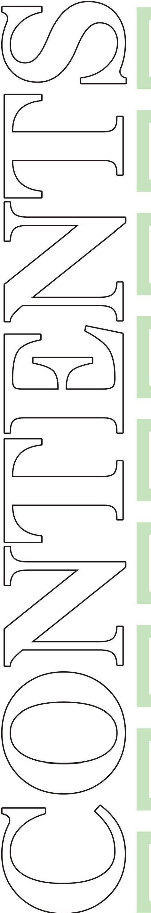

7

**LETTER TO EDITOR:**

**37**

# TRANSCRANIAL MAGNETIC STIMULATION -

AN EMERGING SIGN OF RELIEF FOR PSYCHIATRY IN DEVELOPING WORLD

*SYED ARSALAN ALI, SYEDA A/MEN WAQAR*

**CREATIVE CORNER:**

**38**

# PSYCHOLOGICAL FIRST AID

***COURTESY:***

*ARTS* & *PAINTING EXHIBITION 2016 ORGANIZED BY NET/ZENS,* PUNJAB MEDICAL COLLEGE, FAISALABAD

**39**

**INSTRUCTIONS TO THE AUTHORS**

*JULY* - *SEPTEMBER 2016* I *VOLUME 13 NUMBER 3 PAGE OS*